**Use test – Demonstrate the buggy behavior**

The Hotel Booking System use case test performs to demonstrate the buggy behavior of the Hotel Booking System in User Acceptance Testing form.

There are two bugs are reported as following:

1. All Service charges are reported as $0.00 when checking out.
2. It is possible to charge a room for service after the guest has checked out.

| **Test Name** | Hotel Booking System - Use Case Test |
| --- | --- |
| **Use Case Tested:** | Hotel Booking System |
| **Test Description:** | The Hotel Booking System use case was performed to test the whole hotel booking system functionality. This software is use by user for hotel services purpose in the hotel for instance book a room or any other hotel services. Firstly, user can book a room and get a booking confirmation number which will need for check In. After check in the user can add other hotel services by choosing specific service. On check out user can pay the whole amount including extra services. |
| **Pre-conditions** | Firstly, user will see a main menu of the Hotel Booking System and can choose any option accordingly. |
| **Post-conditions** | 1. Normal flow and alternative flows where Hotel Booking System is successful.  * The user can book a room successfully. * User can check in successfully. * User can add other services successfully.  1. All other unsuccessful scenario.  * The extra added services amount showing zero on check out. * Customer can be charged for other services by hotel after checked out. |
| **Notes:** | **Extra services cost not included in the final bill and it is possible to add extra services after checked out.** |
| **Result (Pass/Fail/Warning/Incomplete)** | **Failed** |

|  | **TEST STEP** | **EXPECTED TEST RESULTS** | P | F |
| --- | --- | --- | --- | --- |
|  | User can book a room | * Prompt to enter the booking details. * Choose the room type and enter other required details. | Yes | No |
|  | User can check in | * Prompt to enter confirmation number. * Prompt to confirm check in. | Yes | No |
|  | Add other services | * Prompt to choose services. * Prompt to enter the cost. | Yes | No |
|  | Check out | * Prompt to enter the room number display the room details. * Display the total bill including extra services charges cost. | No | Yes |

Following screenshot demonstrate the first reported bug:

Test results are failed because of buggy behavior of the Hotel Booking System.

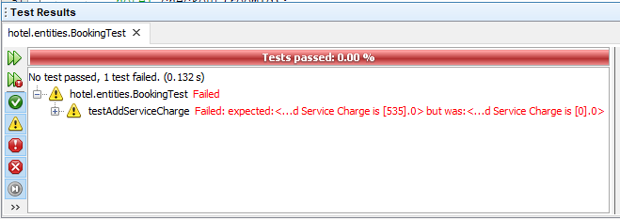

Following screenshot demonstrate the second reported bug:

Test results are failed because of buggy behavior of the Hotel Booking System.

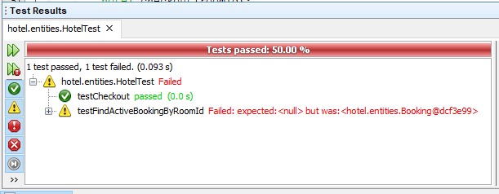

**Debugging log**

For tracing the bugs Netbeans IDE being used and run the Hotel Booking System as debug mode to find the code which is the reason of the buggy behaviour of the system. Following table demonstrate the unsuccessful flow.

|  |  |
| --- | --- |
| **Display main menu again – Record service** | |
|  | 1. Prompt to enter the one of the selected latter (B, C, R, D or Q). |
| 1. Type (R) for record services | 1. Display following:  * Display services types * B: Bar Fridge * R: Restaurant * S: Room Service * Prompt to enter service type |
| 1. Enter service type | 1. Prompt to enter service cost |
| 1. Enter service cost | 1. Display following:  * Services details including cost * **Store cost value.** |
| 1. Hit <enter> to continue | 1. Record service completed |
| **Display main menu again – Checking out** | |
|  | 1. Prompt to enter the one of the selected latter (B, C, R, D or Q). |
| 1. Type (D) for check out | 1. Prompt to enter room number |
| 1. Enter room number | 1. Display following:  * Display booking details * Display service charges cost **$0.00** * Display total cost **$0.00** * Prompt to accept charges? (y/n) * **Remove the room from the active booking list.** |
| 1. Enter (y) to accept charges | 1. Display the cost and prompt to enter the credit card details. |
| 1. Enter credit card details | 1. Display debited amount **$0.00**. |
| 1. Hit <enter> to continue | 1. Display checking out completed. |

**Output of the origin of each bug**

**First reported bug - Record services cost shows $0.00 on checking out:**

The normal flow is required to display the correct cost not the $0.00 at checking out.

The usage of variable is not correct that is why the entered cost is not passing to the required method which could store the value and the unit testing result is also failed because of it.

**Unit test output:**

The test result is failed because of the buggy behavior as the method does not store the value that is why expected and actual result is different.



**Source code screenshot:**

In the following screenshots the error is highlighted. At present, addServiceCharges() method only store the service type not the cost as output displays the only service type however service cost is $0.00.

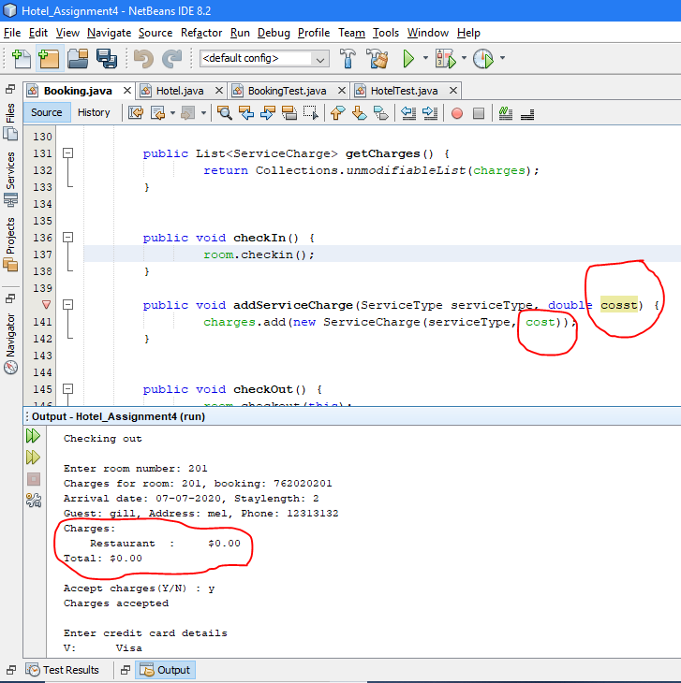

**Second reported bug - It is possible to charge a room for service after checked out.**

The normal flow is required to display no booking present for the specific room at record services for the guest who has checked out.

The method implementation is not correct that is why the room is still showing active after checked out however it needs to be removed from the active list and the unit testing result is also failed because of the same reason.

**Unit test output:**

The test result is failed because of the buggy behaviour as the checkout method is not removing the room from the active list that is why testFindActiveBookingByRoomID() method still showing room is active because of test is failed as expected and actual result is different.



**Source code screenshot:**

In the following screenshots the error is highlighted. At present, checkout() method does not remove the room from the active booking list as checkin() method add(put) the room in the active list that is why it is possible to charge for any services after the guest has checked out as the room never remove from the active list.

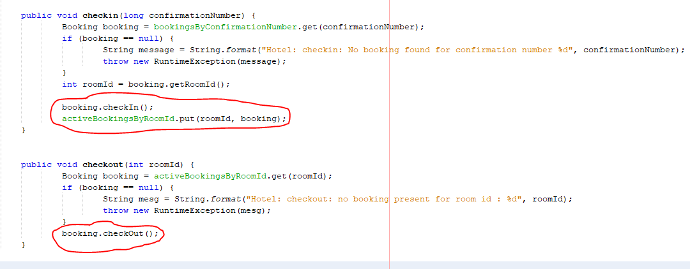

**Output demonstrating correct operation**

**Fixed first reported bug - Record services cost shows $0.00 on checking out:**

The first bug has been fixed by changing the variable name in the addServiceCharge() method which is located in the Booking class of the Hotel Booking System. Now, record service not showing $0.00 however it is showing actual cost as following source code output:

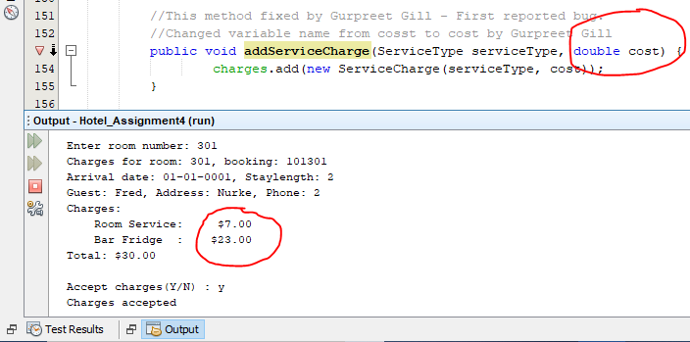

**Unit test output:**

The test result is passed after fixing the method.

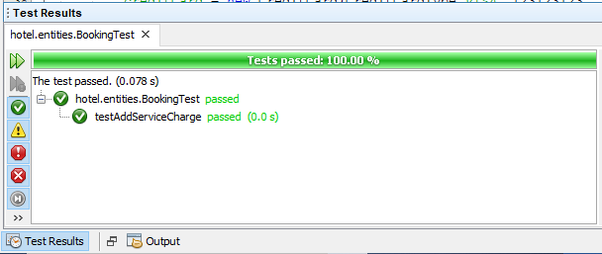

**Second reported bug - It is possible to charge a room for service after checked out.**

The second bug has been fixed by updating the checkout() method which is located in the Hotel class of the Hotel Booking System. Now, it is not possible to charge a rrom for service after checked out as following source code output:

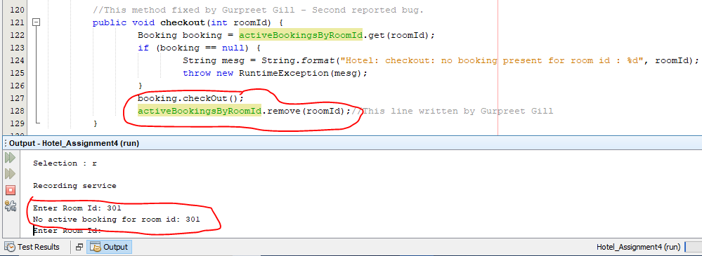

**Unit test output:**

The test result is passed after fixing the method.

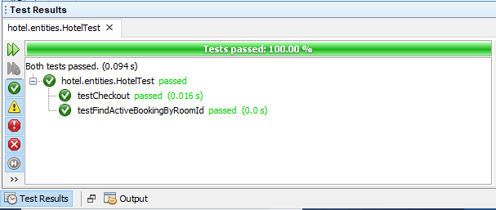

**GitHub feature branch folder link:**

[https://github.com/tgcsu515/Assignment4_HotelReservationSystem/tree/11622931_GurpreetSinghGill/src/hotel](https://github.com/tgcsu515/Assignment4_HotelReservationSystem/tree/11645658_AmandeepKaur)